The Curling Chip March/April 2022

FLICKERTAIL WOODCARVERS
PO BOX 7473
BISMARCK ND 58507
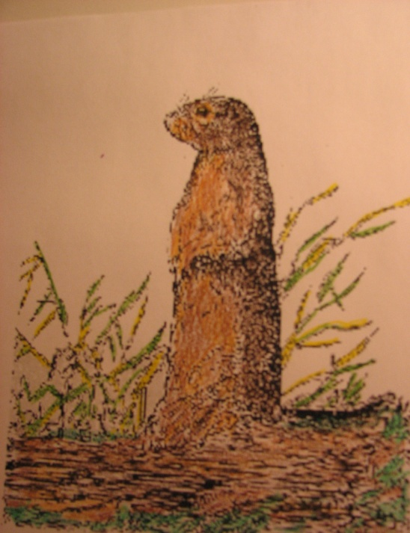
While this newsletter is a bit late coming, it contains information for the this summer’s activities. Potlucks are always fun to look forward to and the first one is June 21st from 6-9pm at Sertoma #5. Sign-ups for summer demonstrations will be available at the potlucks. And Bob is collecting past project items for the library display. Some from years ago may be interesting to remember.
Thanks to Becky B, Eric G and anyone we have forgotten for help with the finished product. We hope you enjoy the results.
We hope you enjoy the newsletter. For questions or future articles send your info to Tom/Diane Turck at email address tdturck@bis.midco.net. Good Carving!

Newsletter Team: Tom Turck and Diane Lehman Turck__
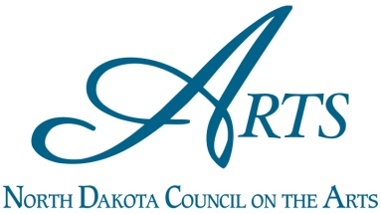

Website: https://flickertailwoodcarvers.org/
Facebook - https://www.facebook.com/flickertailwoodcarversnd/
Pintress - https://www.pinterest.com/flickertailwoodcarvers/

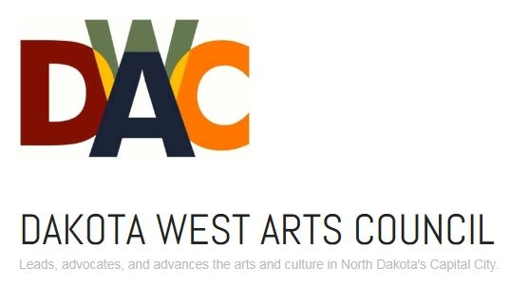
Flickertail Woodcarver projects are supported in part by grants from the North Dakota Council on the Arts, which receives funding from the state legislature and the National Endowment for the Arts. They are also supported by grants from Dakota West Arts Council and Montana Dakota Resources Group.
Event Calendar
Meetings and Whittle-Ins are held at Trinity Lutheran Church in Bismarck

Summer – June, July and August at Sertoma Park, Shelter #5

Website - https://flickertailwoodcarvers.org/ Instagram - @flickertailwoodcarvers
Facebook - @Flickertailwoodcarversnd Pinterest - @flickertailwood
Twitter - @FlickertailND Email - flickertailwoodcarversnd@gmail.com
March 5, 2022 Monthly meeting 8:30-10:30 AM
Project by Ed Ryen – Photo Editing
March 15, 2022 Whittle-In, 7-9 PM
Project by Cliff Orgaard
April 2, 2022 Monthly meeting 8:30-10:30 AM
Project by Bob Pedigo – Knife Sharpening
April 19, 2022 Whittle-In, 7-9 PM
Project by Becky Barnes – Sweater brooch
April 29 – May 1 Red River Valley Wood Arts Festival – Fargo Air Museum
May 6-8, 2022 Spring Carving Class – Dennis Houle. Woodcarving / Cultural lesson / Art class
May 7, 2022 Monthly meeting 8:30-10:30 AM
Project by TBD
May 17, 2022 Whittle-In, 7-9 PM
Project by Mike Knudson - Norwegian Independence
June 21, 2022 Picnic at Sertoma Park #5, 6-9 PM
June 24-26, 2022 Wahpeton Carving Weekend
June 26, 2022 Museum Alive, Walsh County in Minto
July 19, 2022 Picnic at Sertoma Park #5, 6-9 PM
July 30, 2022 Blue Grass goes Pink, Cross Ranch State Park
August 6-7, 2022 Capital A’Fair, Capital grounds
August 16, 2022 Picnic at Sertoma Park #5, 6-9 PM
August 20-21, 2022 Corn Fest, Buckstop Junction
September 3, 2022 Monthly meeting 8:30-10:30AM
Project by TBD
September 20,2022 Whittle-In, 7-9PM
Project by TBD
September 23-25, 2022 Applefest, Buckstop Junction
October 1, 2022 Monthly meeting 8:30-10:30 AM
Project by TBD
Oct 6-9, 2022 Flickertail Woodcarving Show
Bismarck Public Schools Career Academy
October 18, 2022 Whittle-In 7-9PM
Project by TBD
November 5, 2022 Monthly meeting 8:30-10:30AM
Project by TBD
November 15, 2022 Whittle-In, 7-9PM
Project by TBD
December 3, 2022 Monthly meeting 8:30-10:30AM
Project by TBD
December 20, 2022 Whittle-In, 7-9PM
Project by TBD
December\January Winter Celebration unknown day
Added Information
Because the March/April Newsletter is late, and the May one won’t be available for a week of two, I’m including this summary of things members might want to know now. Most are mentioned in the newsletter as well.
- Our first potluck of the summer is on Tuesday, June 21, from 6-9PM at Sertoma #5. Bring something to share if you can, but came anyway. This is for all family members and open to the public. Bring a project, a Show and Tell or just come to visit.

- Bob P is collecting items in June and July for the coming library display. He is accepting five carvings from each past project. Please have them labeled with your name.

- There will be sign-up opportunities for demonstrations this summer. Some are:
Walsh County Historical Museum: Minto June 26
Blue Grass goes Pink: Cross Ranch State Park July 30
Capital A’Fair: Capital grounds August 6-7
Corn Festival: Buckstop Junction August 21
Applefest: Buckstop Junction September 23-25
- The Fall Show in October is fast approaching. The Master Carver will be doing a Whimsical tree house design. Eric G is doing the Saturday/Sunday undertaking of a Dala horse and Becky W is doing the non-carving project of two brooms. Registration will begin in July with Bob P taking your information.

___________________________________________________________________________
Monthly Meeting Minutes for Flickertail Woodcarvers
March 5th, 2022
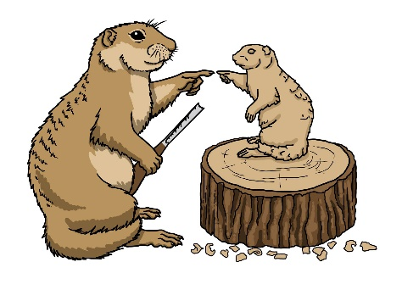
Call to Order by President Becky Barnes Saturday March 5th, 2022
13 Members present

Secretary’s Report (Becky Barnes and Eric Gaasland for Diane Lehman Turck) Last month’s minutes approved.

Treasurer’s Report (Warren Schlecht)
$7,105.57 in account with all bills paid

Committee Reports
Project: thank you to Ed Ryen for his project on editing photographs. He had a useful handout and did a presentation as well on jpg and raw imaging.
Membership (Doug Smith): we’re sitting at around 60 members, several of whom haven’t paid their 2022 dues *yet*, but who probably will. Doug is going to phone a several people to see if they are still interested.
Programs (Dale Heglund): Spring class will be taught by Dennis Houle, with the participants each completing 2 or 3 of four projects including a gunstock war club, a war club, a horse dancing stick and a quirt. The projects will include cultural lessons. Anyone with a special piece of wood is encouraged to bring it. The class will be held on Friday, May 6 to Sunday, May 8 at Dale and Jen’s home. Friday and Saturday the schedule will be from 10-4, and Sunday from 10-2. Class size will be limited to 12 students each paying $50. The remainder of the cost is covered by a grant.
For the Annual Fall Woodcarving Show, Dale has arranged for Eric G to teach a folk style Dala horse as the weekend session. And Becky W to do the non-carving class instructing students in making a whisk broom one day, and a regular broom the next. Dale is still looking to acquire a Master Carver for the Friday-Sunday seminar.
Publicity & Property (Becky Weisgerber): Becky has a new supply of business cards with information regarding Flickertail Woodcarvers on the front. On the back is the photo of an artifact such as spoons or Dala horses, or the act of carving highlighting things like a glove or a chainsaw.
Library (Todd Englestad): nothing new
Historian (Clara Yonker): NA
Facebook (Eric Gaasland, Dale Heglund, Becky Barnes): up to date. We are still receiving messages and Facebook visitations.
Website (Becky Barnes): The Fargo show (April 29-30 and May 1), and the Wahpeton Woodcarving Weekend (June 24-26) have been placed on the website.
Old Business
Library Display (Bob Pedigo): The display at the library will run from August 1-October 31. The theme is class projects. Past classes, beginners’ carvings-anything that’s done or in the process, to show a variety of subjects and skills. We will have a limit of 5 items per class session, so that more recent classes don’t dominate. Bob will collect the carvings in June and July.
The timing will encompass the Annual Fall Show and provide welcome publicity for it.
Bismarck State College Beginning Woodcarving Class: (Becky B) Todd and Eric assisted at the first class. The dynamics of the students is interesting. Ten of 12 registered showed up. One is younger than Becky, and they have a range of experience. Only one bandage was needed and the people had fun learning.
Instructors wishing to assist, please come to Bismarck State Campus, Werner Hall, room 140, March17, from 6-8pm; all are welcome. A BIG THANK YOU to Joe Jewett who donated wood to be used for project blanks!
New Business
July 30: Blue Grass goes Pink at Cross Ranch State Park. It would be good to have a table set up. This is a fundraiser for the Cancer Center.
Website focus: Becky B borrowed an idea from the Music Makers Website. They feature a person, from their group, every month, saying something about themselves. So, for us it would be - how long they’ve been carving, what they like best – that sort of information - just an introduction, a short personal interest story. Becky B started with Clara and would like to do it with others.
Suggestion to add a section on email: for members to be able to sell their carvings. The public would be able to use email to purchase items for sale.
Show and Tell:
Warren had his representations of Johnny Reb and Billy Yank with him.
Becky B had an intarsia owl. She also had an intarsia ox and tiger. The ox was last year’s representative animal in the Asian calendar, and the tiger is this year’s. She carved them in a Pictish style.
Eric T brought a lovely Love Spoon based on Bob P’s class.
Meeting was adjourned.

__________________________________________________________________

March 5th, 2022 Whittle-In
Ed Ryen and Dale arrived early to set up the projector and screen for Ed’s presentation on photo editing. There were 13 members all at the back of the room, fairly well separated at different tables. Ed talked us through the differences between JPG and RAW formats.
He noted that JPG loses detail in photo sharing even between cell phones. PNG (portable network graphics) is a lossless form of sharing. It retains more detail. Digital JPG can be in basic, normal or fine files. Fine files are much larger and can store 19.5 mb of data, whereas basic files contain 1.9 mb of data. Digital RAW saves more color than JPG. JPG is 8-bit format while RAW is 12- and 14-bit format. A 12-bit format has 40 times the information an 8 bit has. To share or print a picture as large as an 8 x 11, or any large print, RAW should be used in order to show it clearly. Don’t use JPG 2000. Ed reported that Office Depot can print larger photos. It is also possible to use Mod Podge photo transfer medium, which is different than Mod podge, to put images of color or black and white on wood, paper, fabric, metal etc. Another achievable type of activity with photo editing is to print in reverse format to have the action shown backwards.
Edited photos can be made better than the original. RAW photos once edited can be saved a number of different ways. RAW editing can enhance colors or shadows. Some software such as Adobe charges $10 a month for using it. Other types are free but have a learning curve. RAW Therapee and DarkTable are free but you might need someone like Bruce Williams or Rico Richardson on YouTube to explain their use. Ed processes photos with DarkTable and finally uses a photo editor called GIMP. Most of the techniques Ed practices are procedures he learned from watching YouTube. Since Bob’s Photo closed several years ago, the only place Ed knows for camera repair is in Mandan on Second off Main. The shop will also clean sensors.
Ed and the audience discussed white box photography. You can make or buy a white box. The box is very white and open on one side to place an object inside. The photo taken then has no shadows. If the item is an artifact or something that size matters, a scale or ruler can be placed in the box as well. Black velvet or crushed velvet can be useful in picturing small items or jewelry because it catches the light. Ed said you need to be aware of the background in your photographs. He also talked maintaining RAW photos in an external drive and about uploading photos on an app, and downloading them to a zip drive. If you do it by the photos’ dates and locations you can have a useful record and can relocate each when you want. Remember that every time a JPG is saved, there is data loss.
Following is the handout that Ed gave out to the audience on the differences between JPG and RAW photography.
Photo Editing
(Using JPG or RAW Images)
Ed Ryen

Why Edit Photos?

Editing photos will ensure your photos look as nice as they can be. If you want to print photos, editing will ensure they look their best, especially if you want to enlarge the photo and frame it.

What Format To Use For Editing Photos

Most people take photos with the camera set to JPG, and there is nothing wrong with, that but, editing is limited if at all. The best way to edit photos is to shoot/have your camera set to RAW format.

Which Format Is The Best?

Benefits Of Shooting JPG Photos
- Image processing is done by camera
- Smaller file size; JPG’s are stored as compressed files, so take up less storage
- Sharing, posting, and printing your photos is much quicker if you shoot JPGs

Drawbacks Of Shooting JPG
- Loss of detail. Since your camera compresses the image, the photo will be grainy, flat or pixelated. Not good if you are shooting close up for detail.
- Loss of color options. JPG’s are 8-bit, limiting their color and tone availability.
- Lower dynamic range. This is the difference between dark and light areas of your photo.

Benefits Of Shooting RAW Photos
- High quality image files. Camera captures all available data; no detail or color is eliminated from photo like JPG
- Increased brightness. RAW files have up to 16,384 levels of brightness compared to 256 in JPG.
- More colors. RAW files have 68 billion colors RAW 12 bit, while RAW 14 bit will have trillions of colors. RAW captures as many colors in an image as possible, creating photos with a higher color range and color depth. JPG capture up to 16 million colors.
- Higher dynamic range. RAW captures a lot of light and shadows, ensuring an over/under exposed image can be easily adjusted.
- Process and edit files to your standards. RAW files are made to be edited to suit the needs of the photographer. Once edited they can be save in any photo format.

Drawbacks Of Shooting RAW
- Larger file size. A 16 megapixel camera will have a RAW file of 33.3 MB, while a JPG will be 2 to 6 MB.
- Image processing is required. Software is needed to edit and process the RAW file.
- Software compatibility is a must. For example, Nikon software cannot open Canon RAW files and vice versa. Other editing software* like Adobe products or open source software can open any RAW file.

So which format is best….it’s your choice.

*Editing software. To process RAW photos you need additional software. The most used software was Adobe LightRoom and Adobe PhotoShop. But since Adobe started “renting” their software to users, they aren’t as popular as they used to be, except by the “die hards.”

Open source is software developed by individuals or groups and is available for free. These developers will also give you the programming code if you want to experiment with the software.

Open source LightRoom alternatives: DarkTable, Apple Photos*, RawTherapy, digiKam, LightZone and many others. (*Only for IOS, the other’s mentioned here work on any platform)

Open source PhotoShop alternatives: GIMP, Krita, Paint.net, Photoscape and Sumopaint.

The software I use is DarkTable for processing, and GIMP for final editing and enhancements.

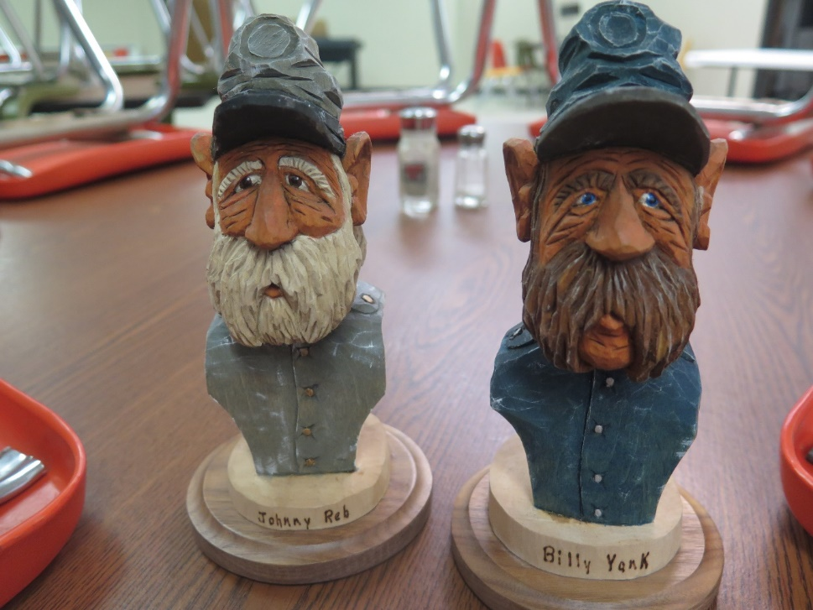
Warren’s Civil War soldiers
Ed revealed that he controls the settings on his Nikon rather than using the automatic feature. That means among other things that he can underexpose or overexpose the film. Darker images than reality are underexposed, while lighter images are overexposed. The photographer can develop the film to compensate for these conditions and get a more interesting picture. Professional cameras can use larger memory cards offering greater capacity and speed.
A few people brought in items for Show and Tell. Warren had depictions of Johnny Reb and Billy Yank. He had loaned them to a teacher who, in teaching about the Civil War, had divided her class into Rebels and Yankees. The busts gave the children a visualization of how the different sides appeared.
Becky B brought three intarsia pieces. One was an owl. A bit cross-eyed, he never-the-less is definitely and owl. An ornament, he has a little eye hook attached to his head.
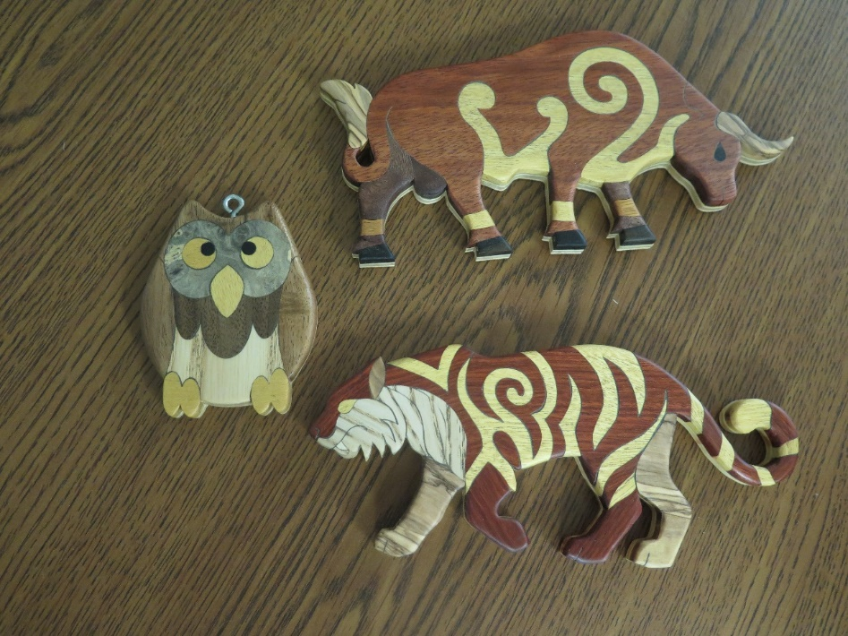
An owl ornament, and an ox and tiger from the Chinese Zodiac in Pictish art
The other two intarsia animals are illustrations from the Asian calendar. They are the ox, last year’s animal and the tiger, this year’s. To bring them more into her heritage, she created them in a Pictish style.
According to Wikipedia, the Picts were people who lived in present northern and eastern Scotland from the 3rd to the 10th centuries along with others. Their name comes from Latin to describe the people’s custom of painting or tattooing themselves. Their art is found on small and large stones in metal and on bone. It is distinguishable although changing over time. Early Medieval carved stones are found, though, throughout Pictish territory consisting of animals, including the “Pictish Beast” along with other designs and patterns. During the early 900s, people began to refer to the Kingdom of Alba instead of the Kingdom of the Picts and the language gradually disappeared. Alba may have been closer to the name the Picts called themselves. There was a Gaelicisation of the area where all of the populations became Gaelicised Scots and Pictish individuality was disregarded.
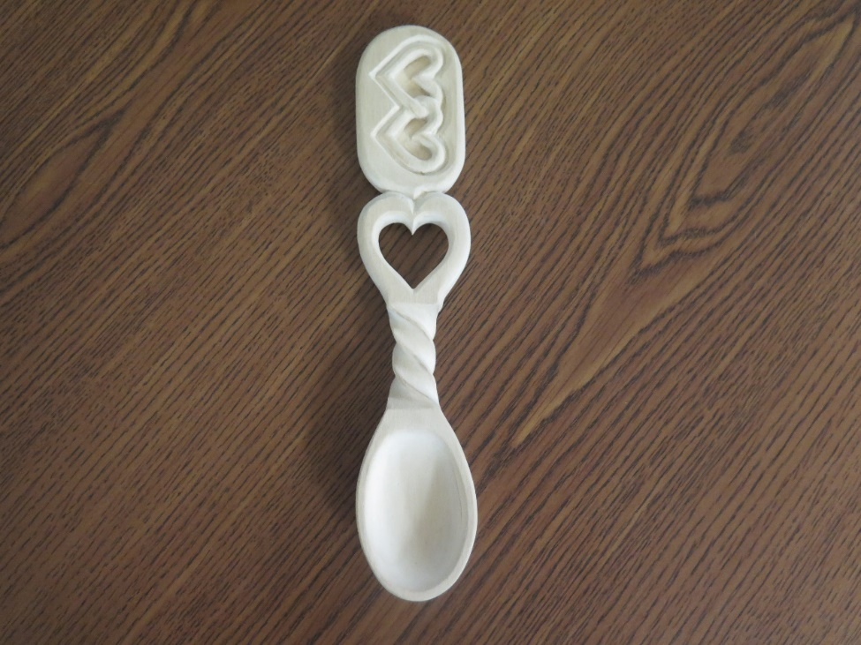
Eric T’s representation of Bob P’s Love Spoon project
Eric T had a lovely well-executed Love Spoon in basswood. Slightly different than the templates Bob P brought in, it does have a twisted stem between the bowl and the handle. The top of the stem has a carved heart with a hollow center. The handle is cartouche shaped with two outlined, intertwined hearts.

_________________________________________________________________

March 15th, 2022 Whittle-In
Cliff Orgaard had the project today and there were 14 people to take advantage of it. His fun plan was What to do with a Spare Block of Wood. He brought with him a number of square blocks about 1 3/8 inches to a side, and five ideas concerning what we could do. The first was a Moravian Star, which was a project a number of years ago with a slightly bigger block of wood. The good thing about a Moravian Star ornament is that it works with any size square block.
The second suggestion was a tiny birdhouse with a slightly concave gable roof. Clearly too small for birds, it has a drilled hole as a doorway and a toothpick for a perch. It could be used for a Christmas or a plant ornament, or an element in a fairy village tableau if you created a front door instead of a bird perch.
The third carving on the sheet was a ball in a cube. That, too, can be made in a larger size. Cliff not only included the drawing of the cube and ball, but he added a template of the curvature to guide you when you’re trying to round the ball. You don’t want to make it too small, or lopsided.
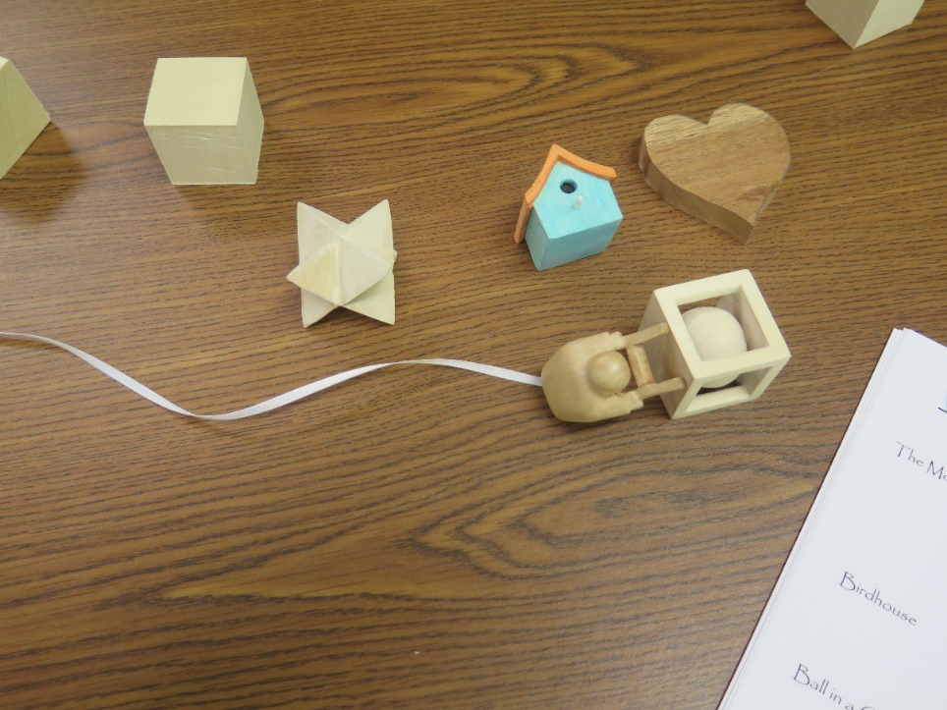
Four of the ideas along with the blank of a Cancer Society heart
The last two patterns on the sheet are called Whimsical bookmarks. The first was a little man bending over with a bookmark of ribbon or some other flat material tied around his waist. The last was a little man climbing up a ladder. There again the ribbon comes off the ladder to mark the page in the book.
Besides the five projects on the paper, Cliff also brought a handful of heart blanks for anyone who wanted to prepare one of those for a cancer survivor.
The ideas were met with enthusiasm. I saw Marlene and Bob P working on the little man on the ladder, Eric T freeing a ball from a cube, Eric G with a heart template, someone was adapting the birdhouse into a small home, and a couple people were carving Moravian stars. There were at least two other tables with members undertaking tasks from Cliff’s piece of paper.
Steve, from Becky B’s class at BSC, came to have Becky B help him with the faces they were making out of wood. They were similar to the Santa faces Rick Skauge had as the subject of his weekend carving class at the Annual Fall Show.

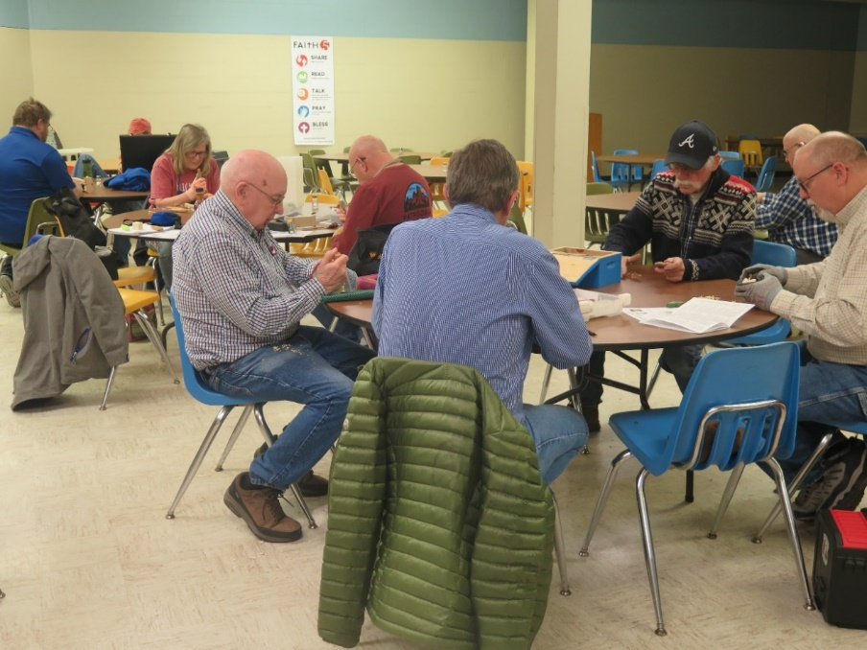
An overview of some of the members at work

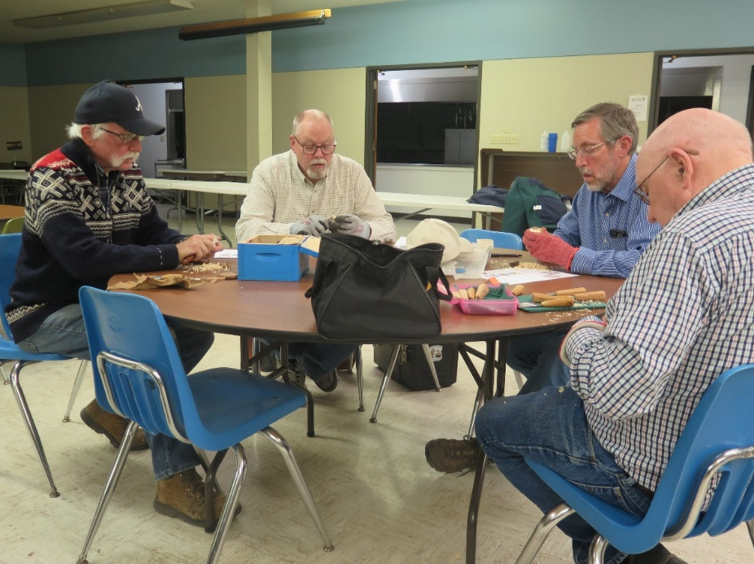
A table of avid carvers
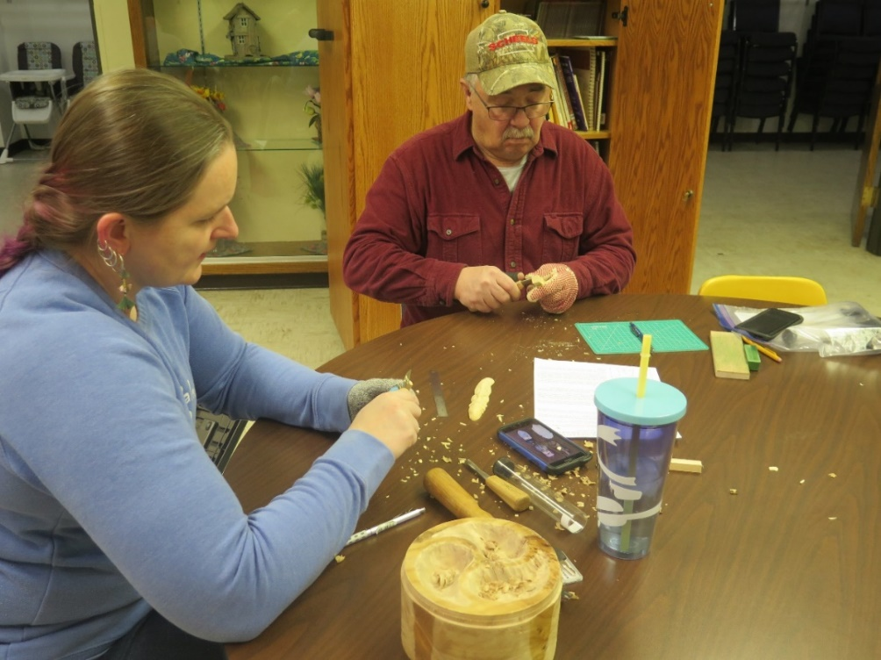
Becky B and Steve creating faces from basswood
Mike showed an old Hagar comic strip he had in his possession. It shows Hagar and his companion trying to hold onto a sea serpent, or maybe a dragon, while an artist tries to model it for the prow of a boat. The artist seems blissfully unaware that the two Vikings have only a tenuous grip on the reptile.
Like many places of work, Becky B’s sometimes has chili cook offs, or competitions to see whose chili or soup wins a taste test. That usually necessitates going up to get a different bowl many times to see which you like best. Becky has found burl, fashioned the sides and flattened the top and bottom so it will stand. Now she is dividing it into three paisley-shaped sections. Each section can hold another type of chili.
Eric T has a cute squirrel that he created in 1980, but he never felt like he finished it properly. He has removed all the coatings he had put on it until it is down to the basic cottonwood. He is fixing the certain parts of it that never pleased him. For instance, the tree trunk and the branches on which he’s standing were plain, without texture.
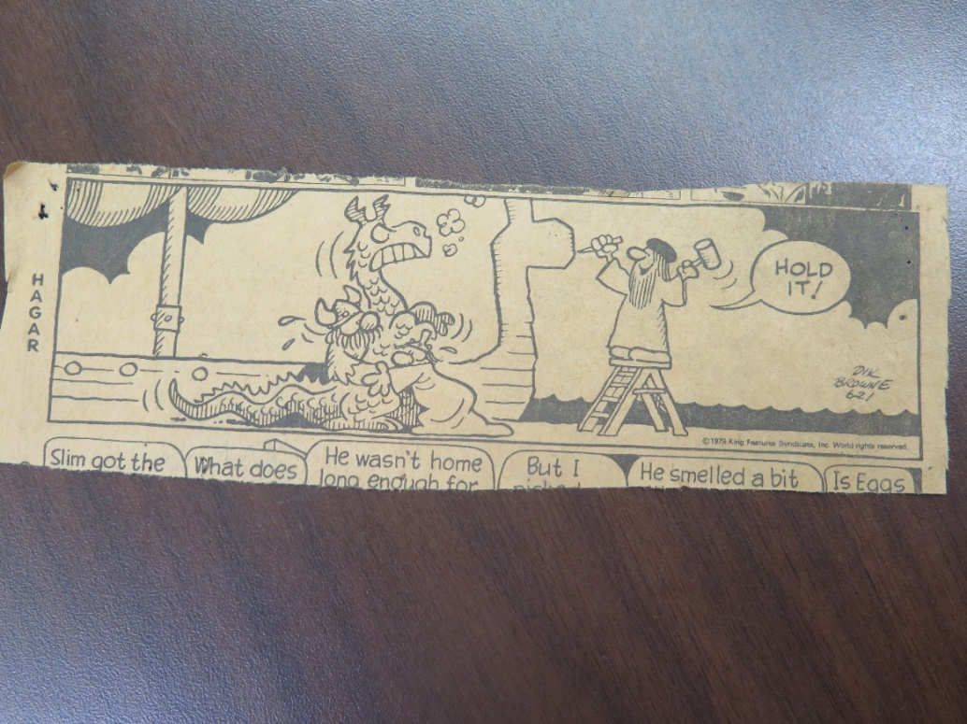
A funny, old comic strip

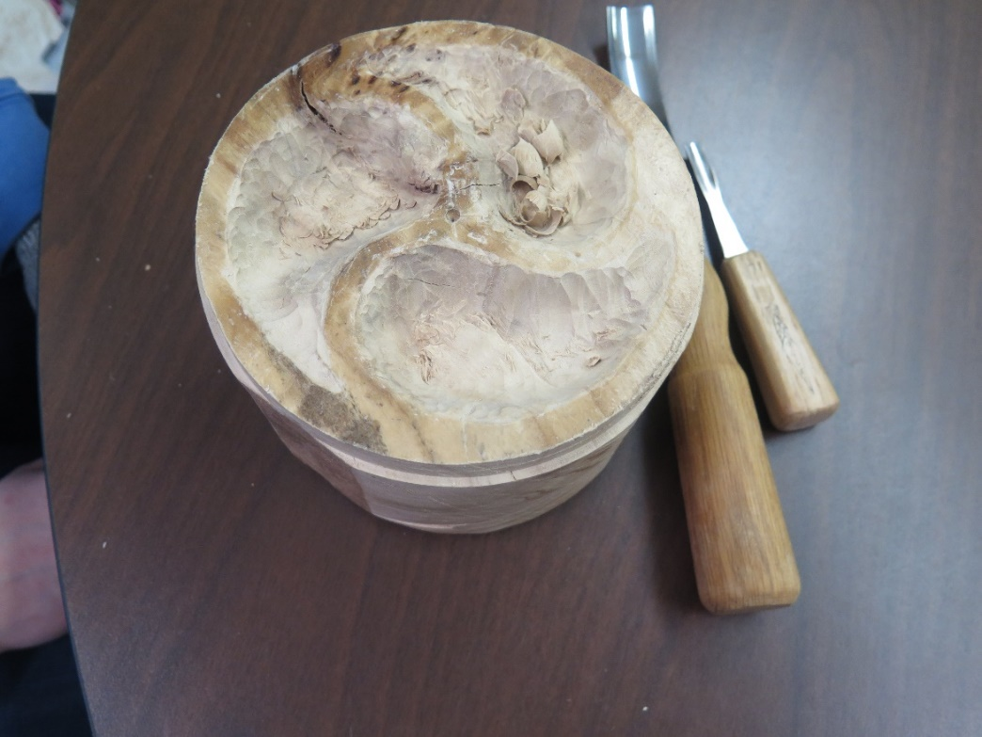
An emerging chili bowl
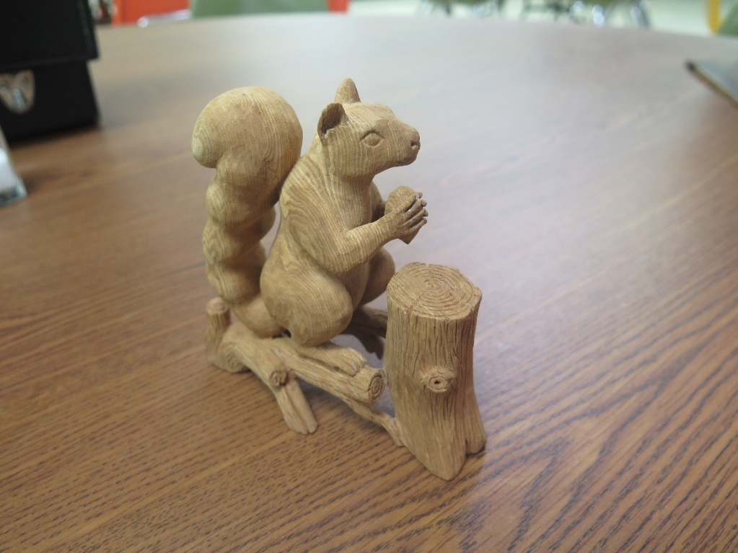
A squirrel and nut with a fluffy tail by a log

_________________________________________________________________

Monthly Meeting Minutes for Flickertail Woodcarvers
April 2nd, 2022
Call to Order by President Becky Barnes Saturday April 2nd, 2022
14 Members present
1 visitor before the meeting, Mary Jane Schmaltz

Secretary’s Report

Cliff moved to accept March’s Report as is. Eric G seconded.

Treasurer’s Report

$10,331.57 in account which includes grant money, and money from BSC in replacement for class costs.

Committee Reports
Project – thank you to Bob Pedigo for leading a tool sharpening session. It’s important to provide one about once a year for new people and as a refresher for everyone else.
Membership (Doug Smith): we’re sitting at around 60 members.
Programs (Dale Heglund): Dale, Becky B an Eric G got together to discuss possible programs for the October Fall Show. They were going to have Charlene Lynum with chip carving, but she has a wedding that weekend. They decided to create a survey to see what folks would like to have here, such as chip carving, caricature, animal, bird, etc. to get a clearer idea of whom to invite. The surveys will be sent out quite soon.
Spring class will be taught by Dennis Houle, on Friday, May 6 to Sunday, May 8 at Dale and Jen’s home. The participants will each complete 2 or 3 of four projects including a gunstock war club, a war club, a horse dancing stick and a quirt. The projects will include cultural lessons. Anyone with a special piece of wood is encouraged to bring it. Friday and Saturday the schedule will be from 10-4, and Sunday from 10-2. Class size will be limited to 12 students each paying $50. The remainder of the cost is covered by a grant. Already seven students have signed up.
Publicity & Property (Becky Weisgerber): NA
Library (Todd Englestad): will take an inventory to discover who has library items out. He will also be addressing gaps in what we have in subjects. For instance, we have no books directly related to knife sharpening, an important topic in carving. Eric G says he has a volume that he can give us. Todd says he will have his name in the front of the book as the donor.
Historian (Clara Yonker): NA
Facebook (Eric Gaasland, Dale Heglund): up to date. Photos from this Saturday are already posted. We are still receiving messages and Facebook visitations.
The Rotary Club in Bismarck has a tradition of making a personalized gavel for each leader depending on his or her occupation. The person who arranged these artistic gavels is no longer available. Mary Jane Schmaltz, says the new president who gets the next gavel, is in the newspaper business. Other gavels were for car salesmen and realtors for example. She and Becky B discussed how the gavel could look and came up with a design. The words printed on the paper would be burned in.
Website (Becky Barnes): up to date.
The Fargo show (April 29-30 and May 1), and the Wahpeton Woodcarving Weekend (June 24-26) have been placed on the website.
Gmail has been having some trouble with the large number of recipients that we send notifications to, so we’ve switched over to MailChimp. Please check your Spam folder/Junk Mail.
Old Business
Library Display (Bob P): The display will center around past projects – classes, beginner projects – anything that’s done or in progress, to show the variety of subjects and skills in the group. A limit of 5 of each project will be imposed, so that more recent classes don’t take over the case. Bob will pick up the items to be displayed at the June and July picnics so that the librarians will have a chance to arrange them in the front cases in the library.
New Business
Dale sent a request to the Parks and Recreation people to reserve a shelter at Sertoma Park for the third Tuesday of June the 21st, July the 19th, and August the 16th from around 5 pm to 9pm. The occasion is a Whittle-In with a grill and potluck meal, and the public is invited. In past years we have had Shelters 4 or 5, and if possible, would appreciate one of those this year.

Show and Tell:
Doug E brought a Mayan Mask from Guatemala. He got it when he was working on a God’s Child development.
Cliff O had two items. A little elephant he created from Marlene’s class several weeks ago. The second was from a Woodcarving Illustrated lesson. It features two Koi fish on a board with magnets to move them around.
Becky B has a little Golem creature made to look like a pine cone with a needle mustache. She also brought the brooches she is going to teach on the April 19th Whittle-In.
Finally Eric T has a Viking face that he fashioned from Becky B’s sessions at Bismarck State College.
Meeting was adjourned.

_________________________________________________________________

April 2nd, 2022 Whittle-In
Every year, Bob Pedigo teaches a session in tool sharpening. In order to carve well, you want to keep your tools very sharp. When you order a tool, it comes with a bevel part way up the knife from the heel to the tip of the knife. Bob sharpens his tools so that they are flat for the whole blade. Where the bevel is on the knife blade determines the angle with which you can carve.
Bob P sharpens the outside of a gouge to about ½ inch back from the edge, rolling the blade from one side to the other and getting it very smooth, polished. The distance back from the edge the gouge is sharpened determines your angle of approach.
A V-tool is composed of two flat surfaces and it is important that they match at the apex. Shape the side bevels. You can situate the apex straight down on the V-tool, detail the bottom a bit forward, or a bit back, which Bob P favors.
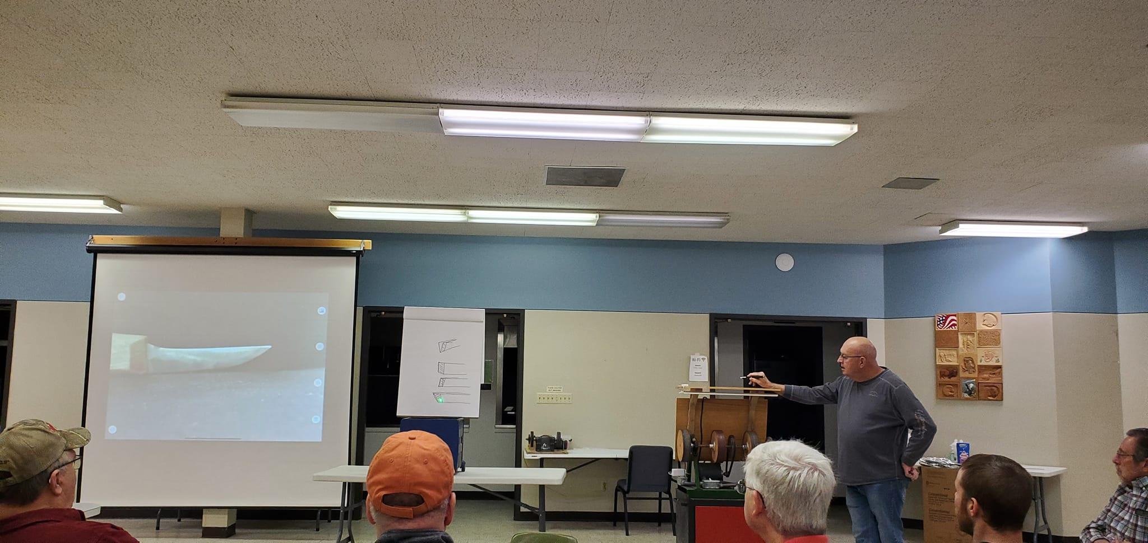
Bob P describing V-tool apexes with a green light. A knife is on the projector.
Flaws on the blade will impede you from getting a smooth and accurate cut. When you have a burr to remove, start with a coarse sandpaper and progress to a fine sandpaper. For most tools, a good job sharpening can be done just using a stone. When you use a strop, pull the blade back and forth using some sharpening compound.
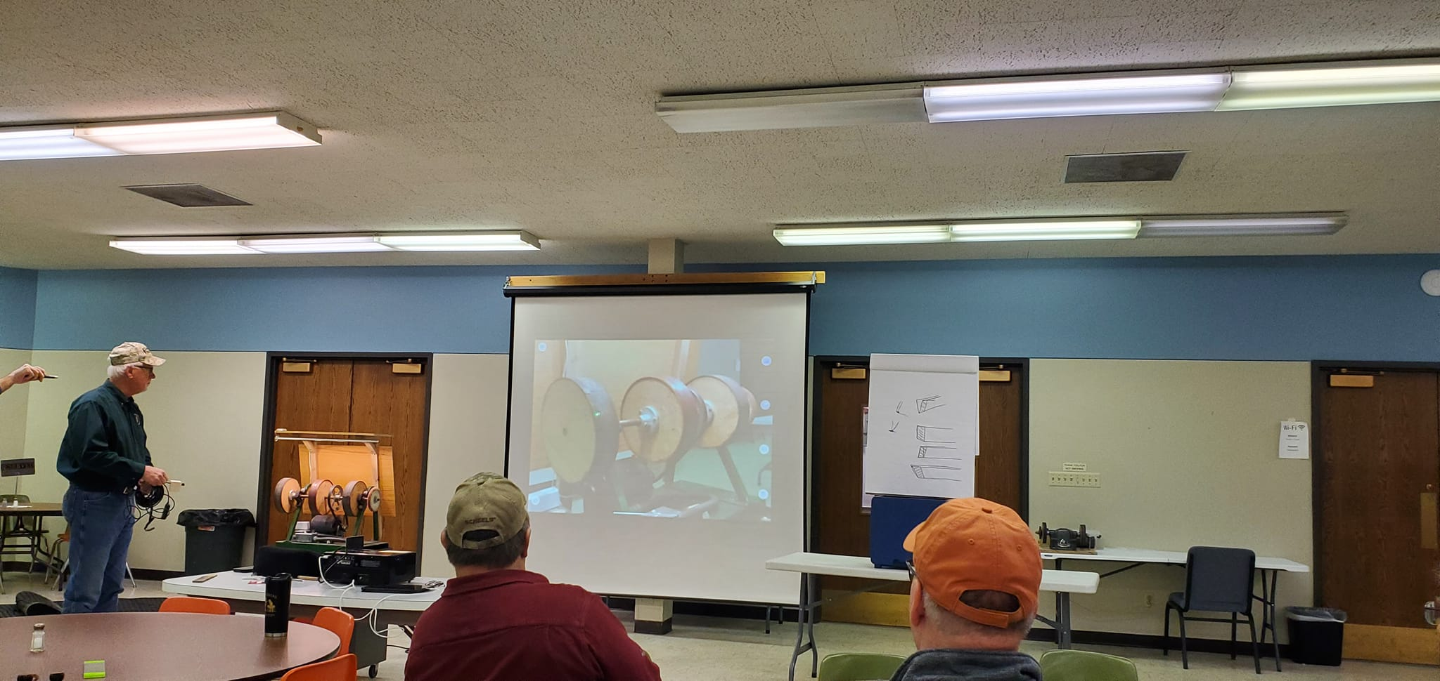
The grinding tool is on the screen
Our club has its own grinding tool, with two wheels of sandpaper with different grits, a strop and a small buffer. When using the tool, it is important to use a spritz bottle with the two sandpaper wheels. They can become too hot and ruin the temper of the knife you are sharpening. Another precaution is to have your fingers on the knife while grinding. It gives you better leverage holding the blade down and you can feel the heat from the wheel and tell when it is getting too warm. The strop wheel doesn’t have that problem and you don’t need to spritz it.
We had a number of Show and Tell items from various sources. Doug E had been working with the God’s Child Project in Guatemala building homes and while there he bought a Mayan mask. He said they came in three sizes, this one being the smallest, but also the best able to fit in his luggage.
Cliff O came with two things. One was a little elephant he carved from Marlene’s class. It is cute and looks like it is trying to find some peanuts. The other is the result of a trip to Florida and an article in Woodcarving Illustrated. Cliff wanted to use cypress which he purchased in Florida to create two beautifully sinuous Koi fish. They are on a cedar tablet. The wonderful thing about them is there are magnets on the back of the fish and there are magnets on the board. It is possible to reposition the fish in any number of ways. Very cool.

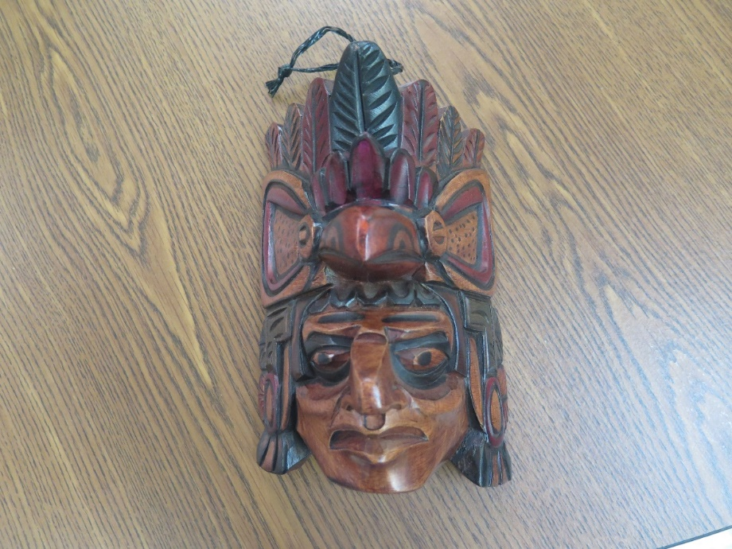
A Mayan mask from Guatemala
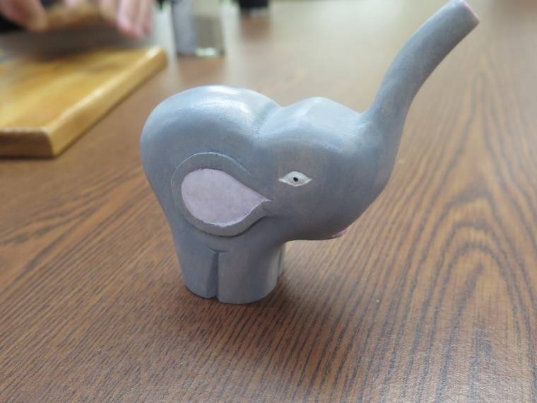
An elephant from Marlene’s lesson
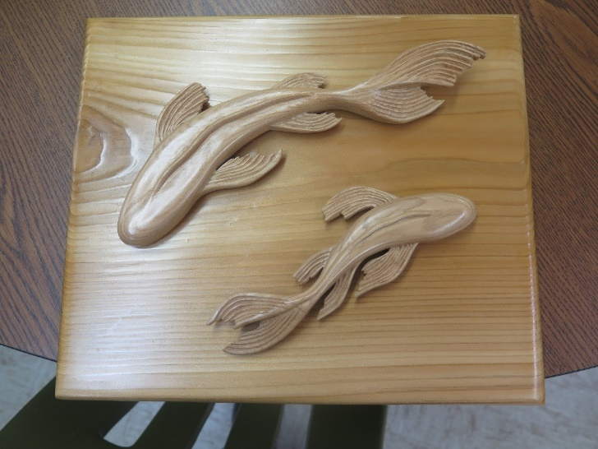
Moveable cypress Koi fish
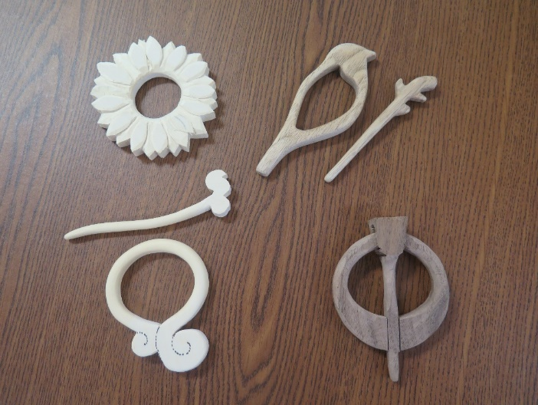
A series of broaches from easy to difficult
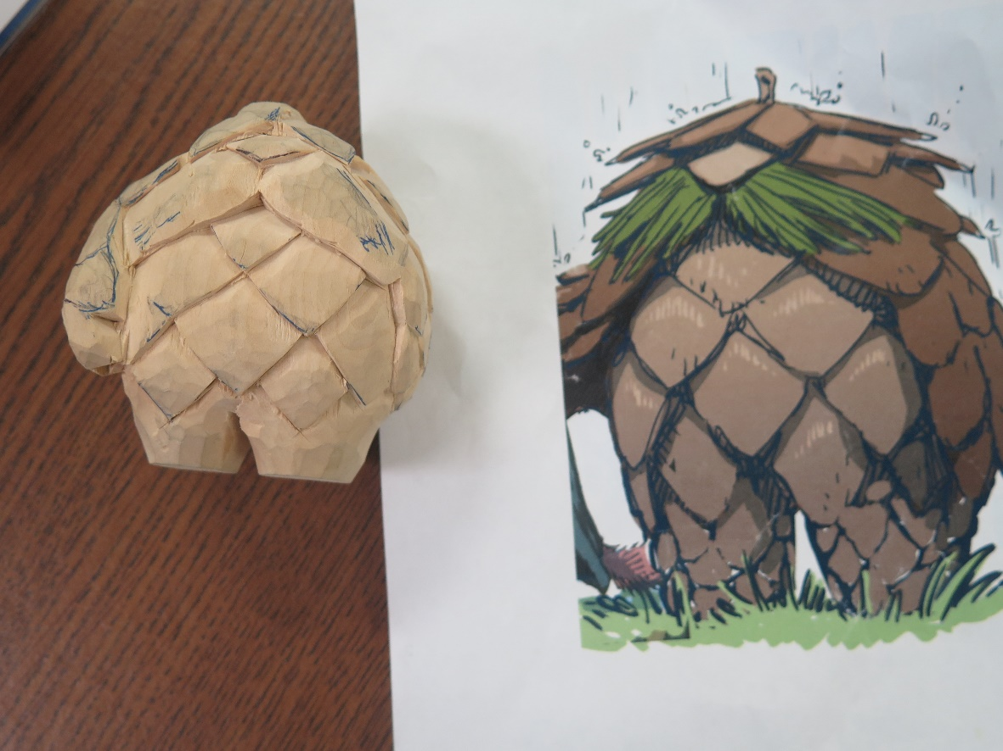
A pine cone creature coming to life
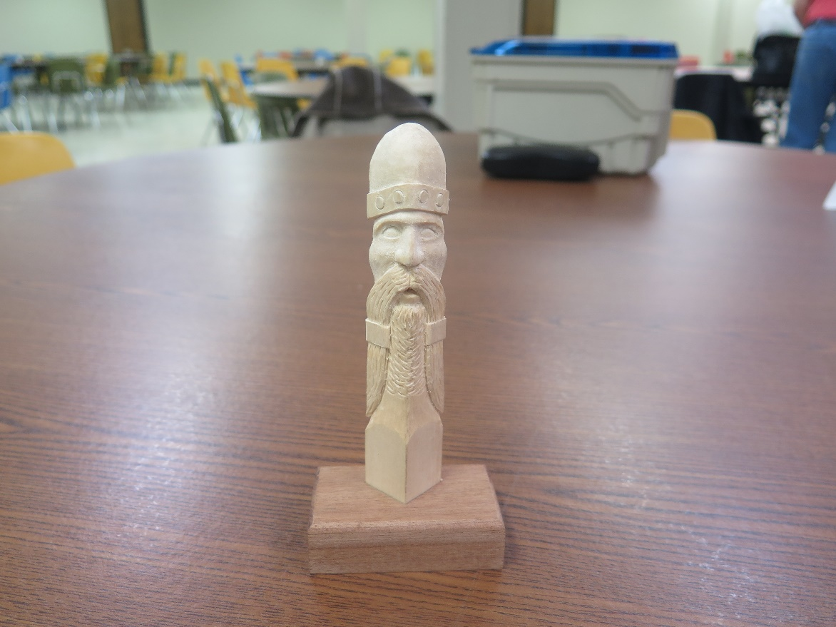
A Viking head statue
Becky B came with the set of brooches she is going to teach for the April 19th Whittle-in. They range from an outline of a bird, to a simple abstract design, to a sunflower and lastly to a more complex penannular pattern with the pin of the brooch within the figure. She then had a little golem figure of a pinecone being that she found online and received permission to replicate him. His body is composed of pinecone scales and he has a pine needle mustache.
Eric T has been helping in Becky B’s Beginning Carving Class. One of the lessons was carving faces. Eric made a Viking face with a helmet that used a tool to make the round motif along the edge. While his beard is long, the ends of his mustache are even longer. He looks a bit like one Becky had fashioned earlier shown in February only hers looks befuddled and Eric’s looks much more serious. Warrior-like?
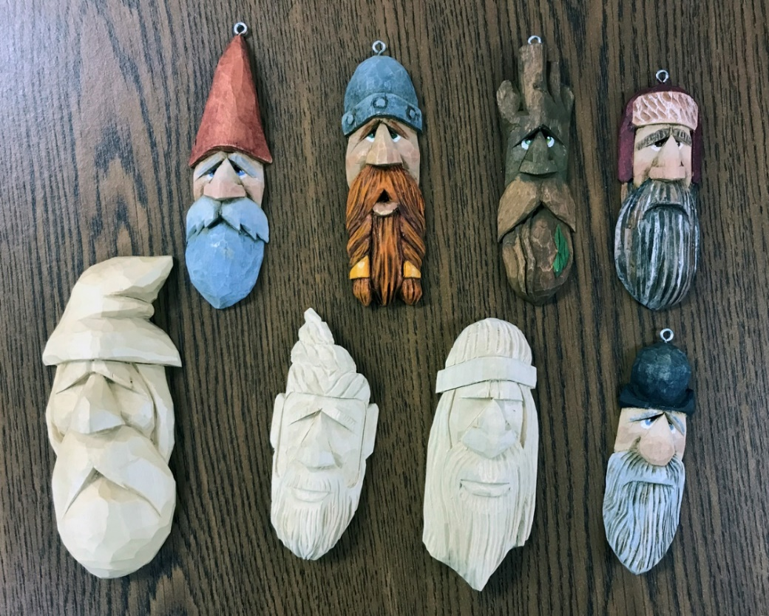
Becky B’s Viking top row, 2nd from the left

______________________________________________________________

April 19th, 2022 Whittle-In
Becky B had a crocheted shawl on one of the tables with a series of brooches pinned to it so people could see how brooches were fastened to clothes. It held the four she had for the lesson today as well as a number of others she created for fun.
The brooches concept was first thought to be strong thorns which held clothes together but by the Bronze Age brooches, were being crafted. In the Iron Age new techniques allowed for modern methods of making brooches, called fibulae (sing. fibula). The Celts used red enamel and coral for decoration as early as 400BC. In Great Britain, the penannular brooch made its first appearance between 600-150BC.
The 5th-8th centuries AD is known for Migration Period Art. It comes from the Germanic peoples settling in Europe and England after the collapse of the Roman Empire and contains a combination of late Roman the new Germanic forms. Inlay and color are the practices famous from this time. Using tiny geometric shapes with stones like almondine, polished flat in cloisonné make it appear like stained glass.
During this time, most Anglo-Saxon brooches showed European and Scandinavian influence. Circular ones first appeared in the middle of the 5th century and by the end of the 6th century were the favorite. Styles changed several times and by the end of the 11th century birds, rectangles and cross motifs were popular.
Celtic brooches were different and elaborate with decorated penannular types and styles containing inventiveness and design complexity.
Scandinavian art from Denmark in the Middle Ages contained Viking motifs using animal ornamentation made of copper alloy or silver. Forms included circular, oval, trefoil and domed shapes replete with animals and birds.
Late Medieval from 1200-1500 saw pentagonal and star shapes along with wheels and heart shapes. Ring shapes were for smaller brooches fastened at the neck. Love, faith and friendship were captured in meaning besides Christian and Pagan symbols. It also ushered in the appearance of three-dimensional brooches.
In the beginning of the renaissance brooches contained gems and pearls and were symbols of wealth and power. In the Georgian period from 1700 to 1830, Josiah Wedgewood influenced the trade with cameo portraits, but fewer were made overall during the time of the French Revolution.
The Victorian era was more somber although cameos still were popular. Hair was often incorporated for mourning or for other reasons. Lockets and hearts were in vogue. In France a reaction to the Victorian era brought in more flowers, women with flowing hair and a freer attitude in the character of brooches. The Edwardian in England in the early 1900s saw the first use of platinum with diamonds. Styles comprised those with ribbons, bows and garlands. Much of this type of jewelry making ended in Europe with WWI.
Art Deco along with artists like Cartier made brooches in the 1920s and 30s. Nowadays people still use brooches. British royalty use safety pin brooches to reinforce diplomatic relations, and politicians use them to make political statements. At Prince Philip’s Memorial, for instance, the Queen wore the Grima Ruby Brooch, made of rubies and diamonds set in yellow gold, he had given her in 1966.
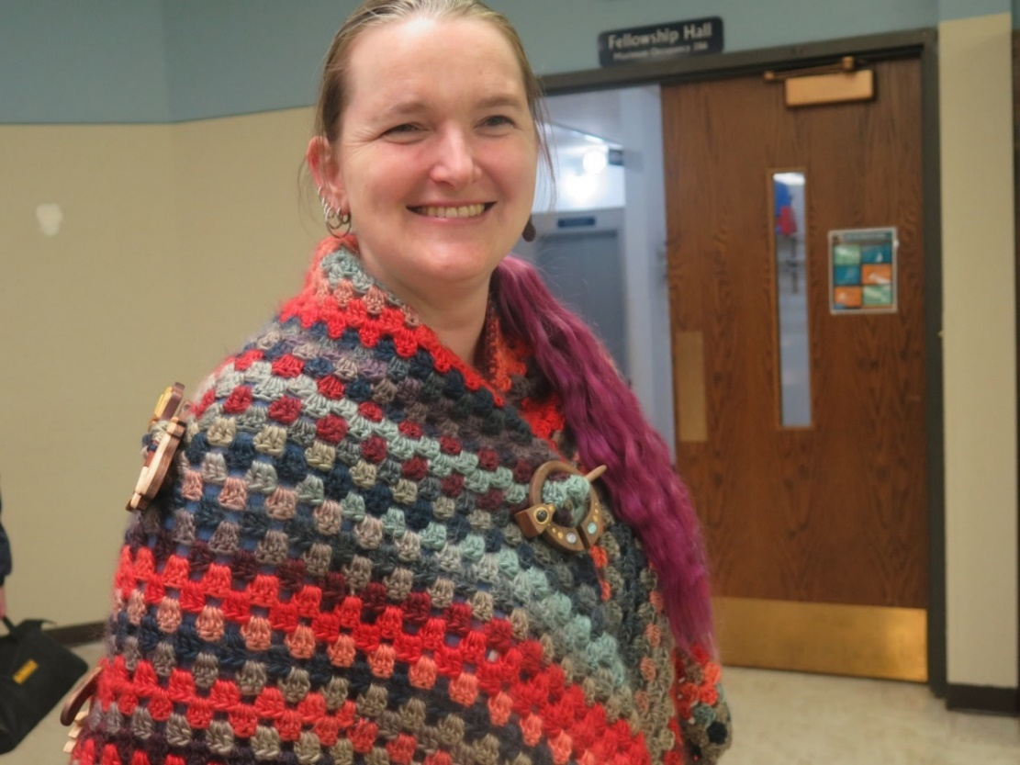
Becky B with the penannular brooch pinning her shawl together
Becky modeled the shawl with the brooches showing on the back and fastening at the front. The penannular brooch is painted with a jewel in the pin. Penannular brooches are circular and their name indicates that they form an incomplete ring. Unlike other brooches the pin is attached by its head to the ring and can move around the circumference. The head of the pin can’t go through the hole, however. Other brooches for the class consist of the outline of a bird with a branch for the pin, a decorative swirl with a swirl for the pin, and a sunflower with a leaf for the pin. The sunflower is the flower of Ukraine.
As stated, Becky created other brooches for fun. On the back of the shawl besides those for the lesson there is a triceratops with a bony frill and a facial defensive horn, a duck-billed dinosaur or type of hadrosaur with a hollow cranial crest, and an ichthyosaur, a fish looking marine reptile that lived in the age of dinosaurs. The pin of the ichthyosaur starts with its long snout and ends with its fish-like tail. And of course there is a fire breathing dragon to complete the menagerie.
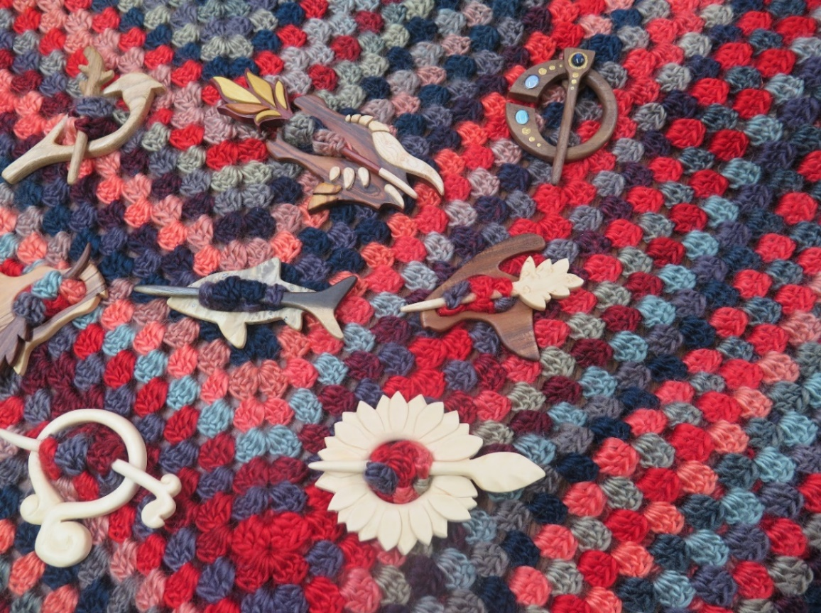
In order from left to right, top to bottom: a bird, a fire-breathing dragon, a penannular, part of a triceratops, an ichthyosaur, a hadrosaur, a swirl and a sunflower
We had 17 people at the Whittle-In, including a friend of Becky W’s named Dylan. Members were working on brooches, Dylan was carving a Christmas tree for a first project for Becky W, and several persons brought in things for Show and Tell.
Mat found an old manual for the Flickertail Woodcarving Club sponsored by Bismarck Parks and Recreation at a sale of old books. Several of the members had seen or had them and there was some discussion of the still useful parts of the pamphlet.
Dale has been in Mexico and returned with an Aztec or Mayan mask that fits him quite well. The center is surmounted by a pyramid and the jaguar is at one side, and a warrior at the other.
Eric T finished carvings from past sessions including a sleeping boar netsuke and a ball free-standing in a box.
Ron had a cute bison he created a dozen years ago with him.
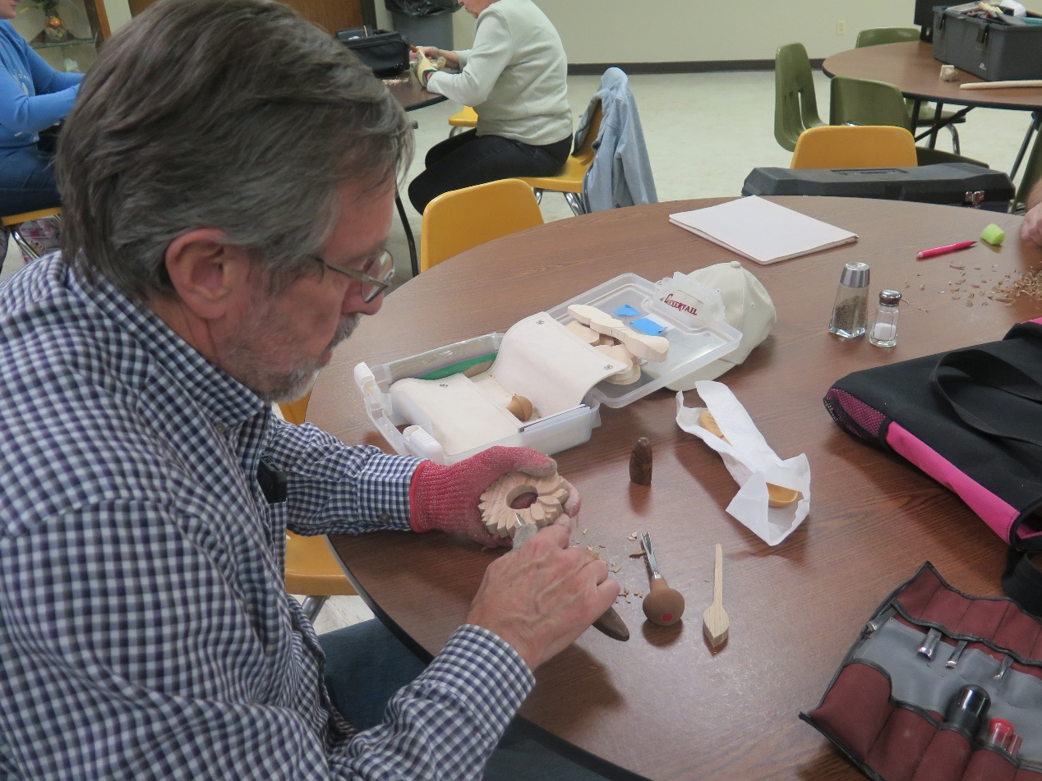
Doug E carving on a sunflower brooch
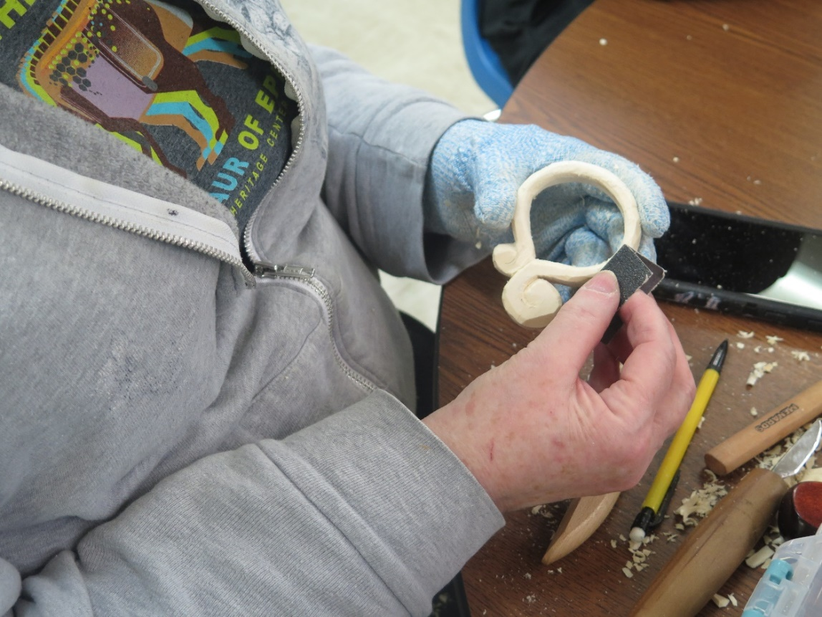
Trissa sanding a swirl brooch
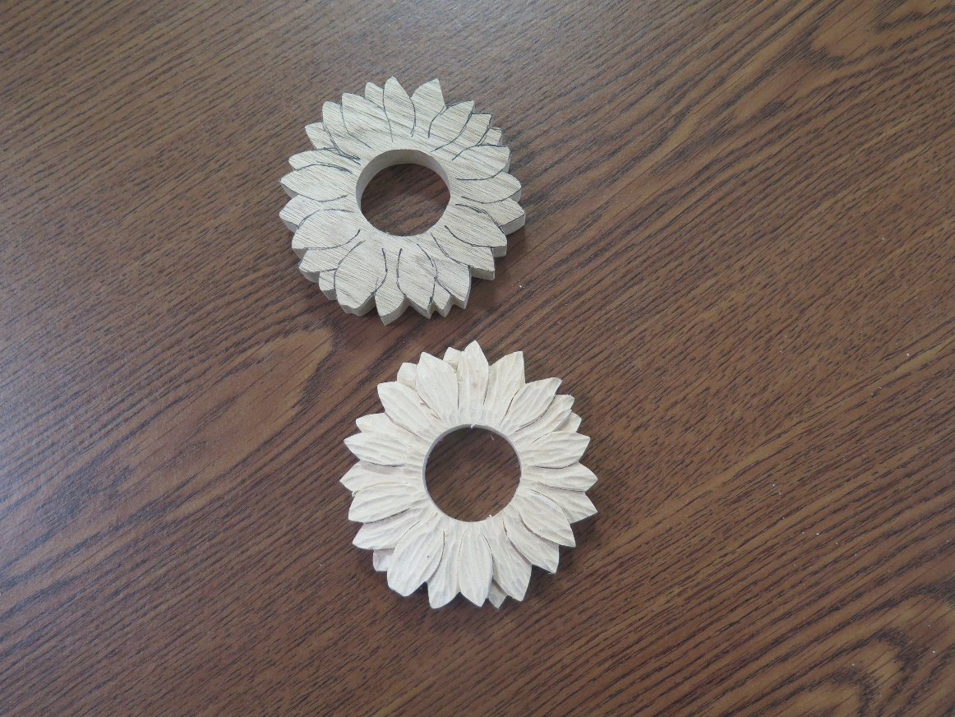
Bob P working on sunflowers
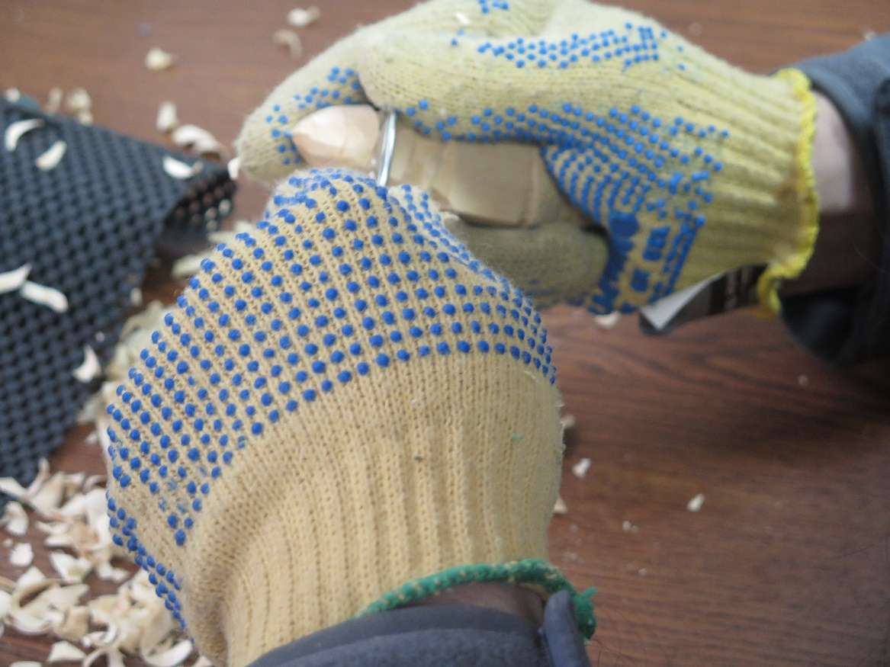
Dylan cutting a Christmas tree
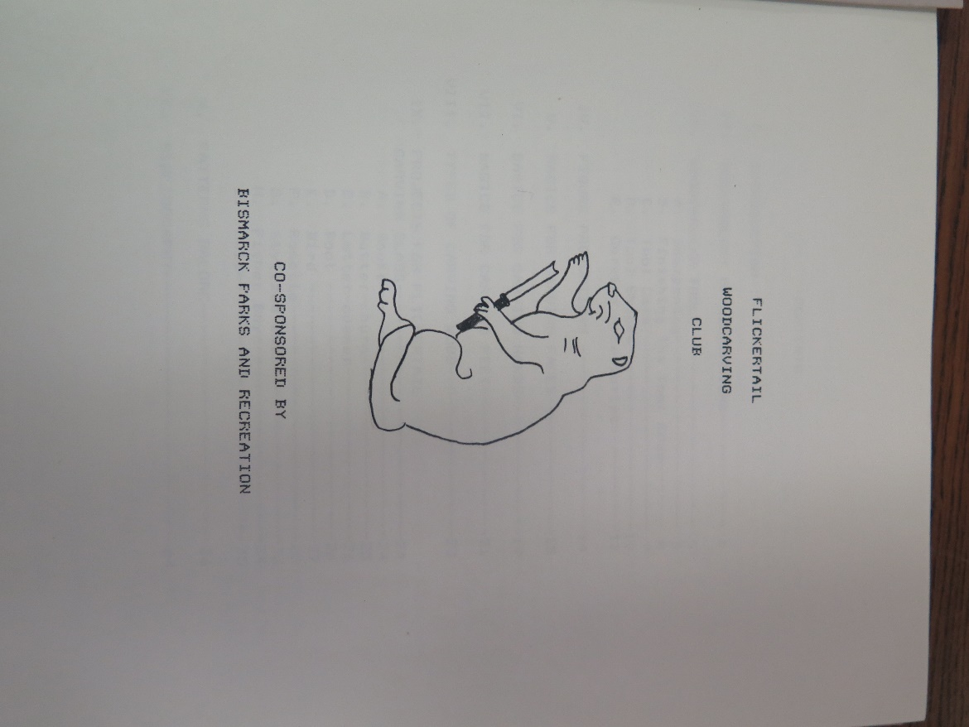
An old Flickertail Woodcarvers Club Manual
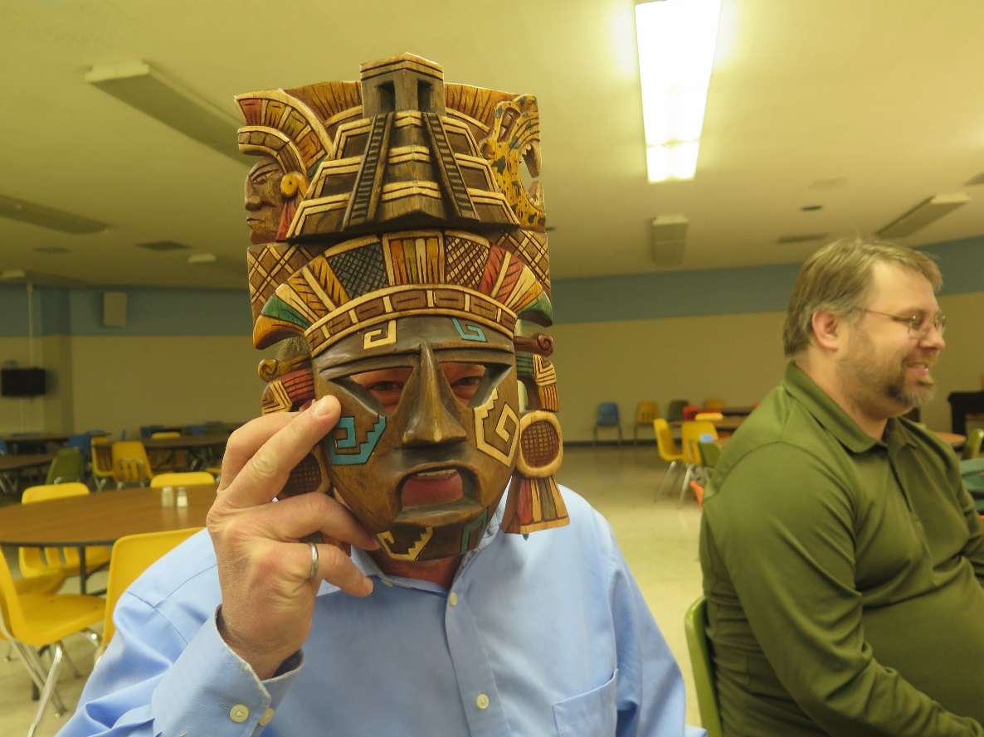
Dale’s colorful Mexican mask
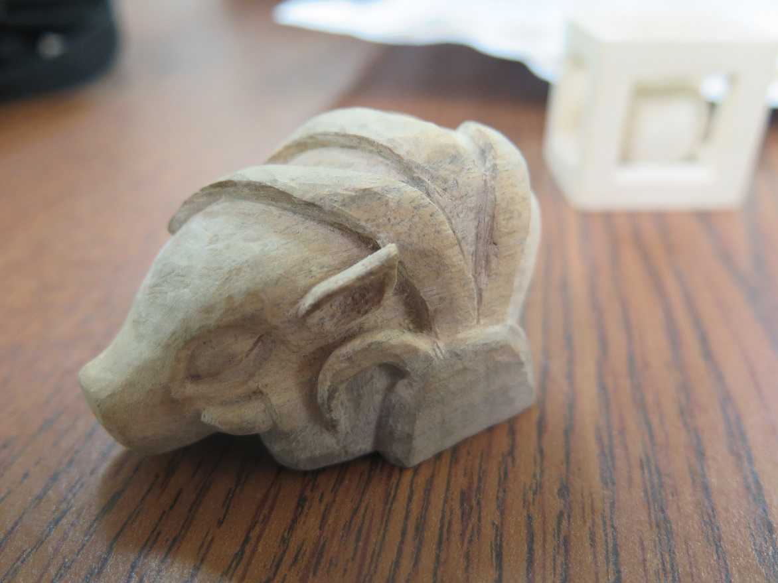
Eric T’s boar from Becky W’s class
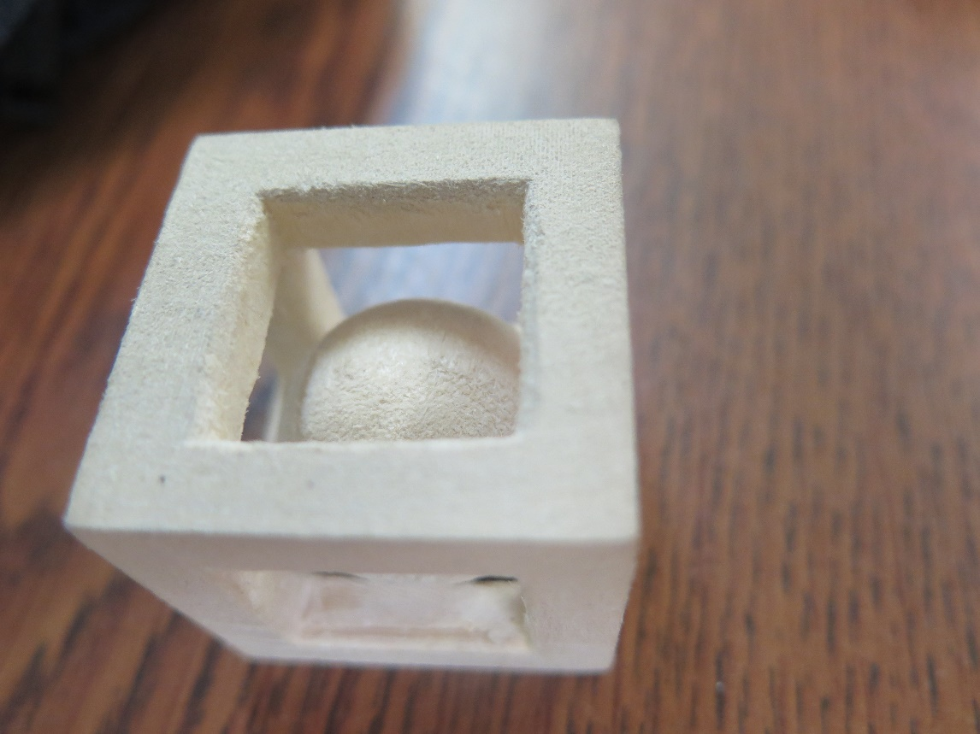
A free rolling ball in a box
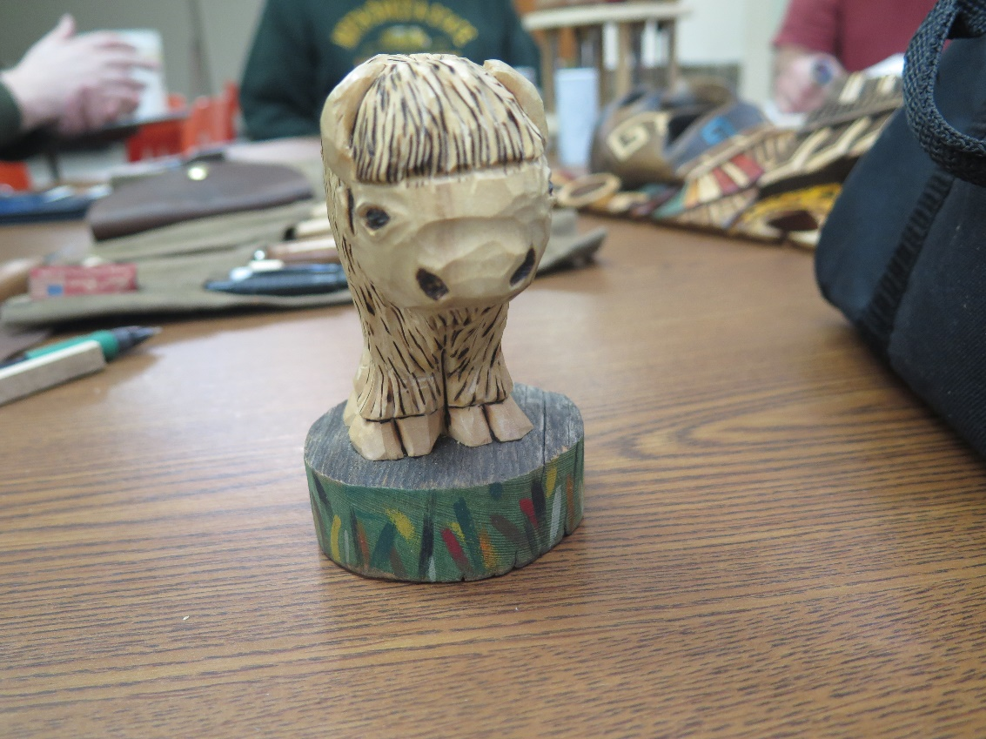
Ron’s foreshortened cute bison
Eileen had manufactured 3 crosses that she makes for religious rosary beads and a heart for the Cancer Society.
Becky B is working on her pine cone Golem, figuring out its arms and its mustache.
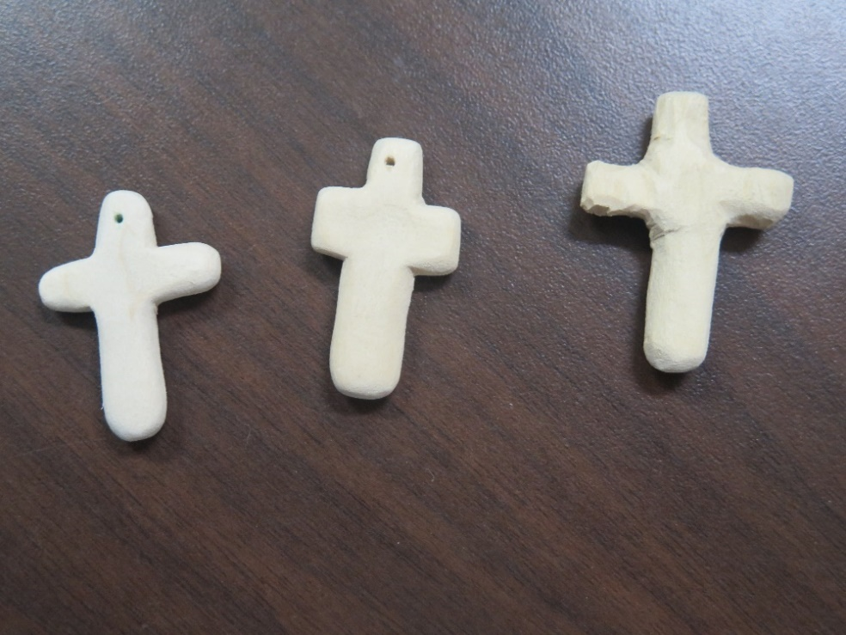
The start of a religious project
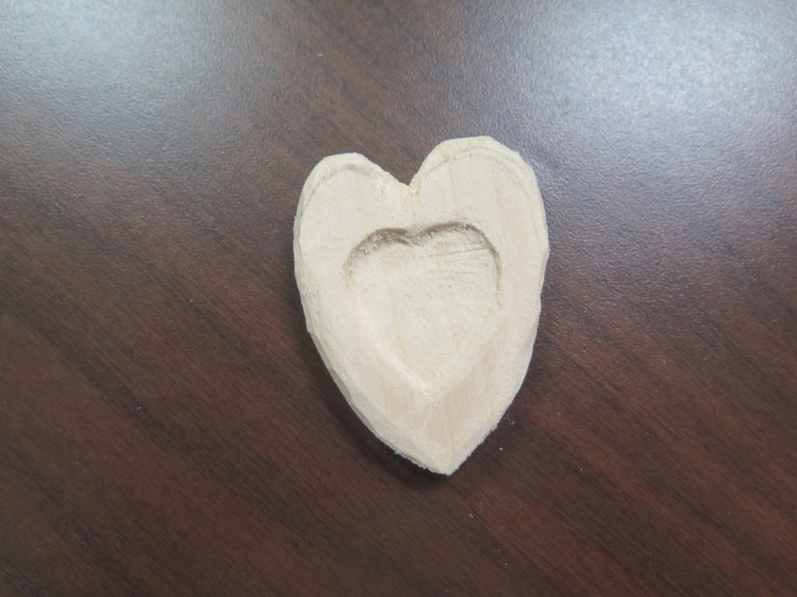
A heart in progress for the Cancer Society
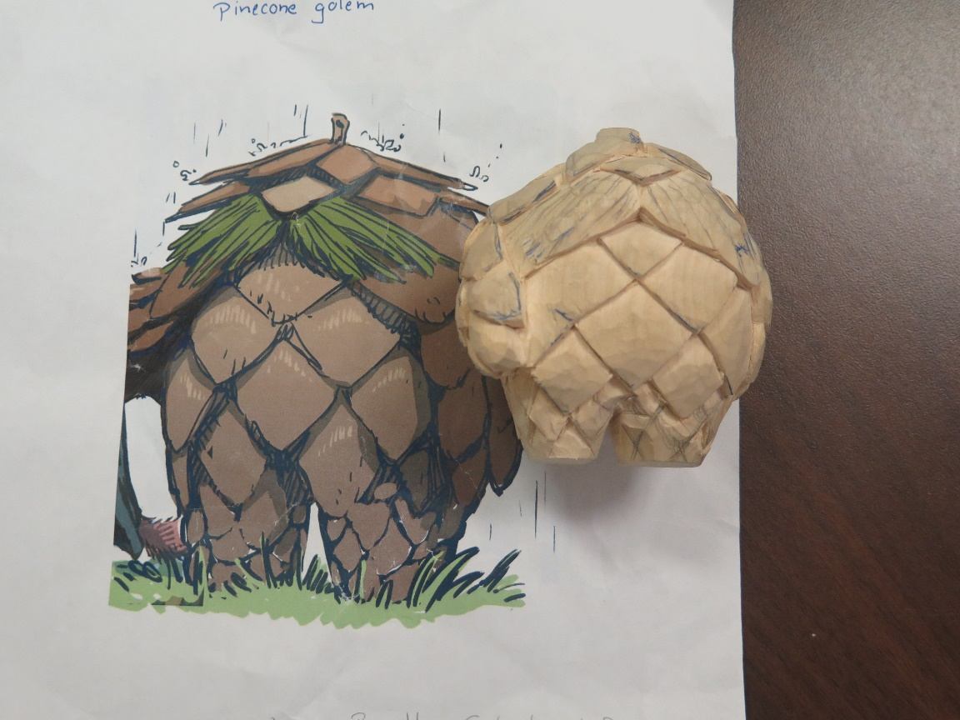
Becky B’s forest creature, pine cone Golem

